SCHOOL OF COMPUTER SCIENCE AND ARTIFICIAL INTELLIGENCE |  |  |  |  | DEPARTMENT OF COMPUTER SCIENCE ENGINEERING
ProgramName:B. Tech |  |  |  | Assignment Type: Lab |  |  | AcademicYear:2025-2026
CourseCoordinatorName |  |  |  | Venkataramana Veeramsetty
CourseCode |  |  | 24CS002PC215 | CourseTitle |  | AI Assisted Coding
Year/Sem |  |  | II/I | Regulation |  | R24
Date and Day  of Assignment |  |  | Week3 - Wednesday | Time(s)
Duration |  |  | 2 Hours | Applicableto  Batches
AssignmentNumber:6.3(Present assignment number)/24(Total number of assignments)
NAME : Shreemayi Katakam
Roll No: 2503B05124
Branch: M-TECH(CSE)

 | Q.No. | Question |  |  |  |  |  | ExpectedTime  to complete
 | 1 | Lab 6: AI-Based Code Completion – Classes, Loops, and Conditionals  Lab Objectives:  - To explore AI-powered auto-completion features for core Python constructs.  - To analyze how AI suggests logic for class definitions, loops, and conditionals.  - To evaluate the completeness and correctness of code generated by AI assistants.  Lab Outcomes (LOs):  After completing this lab, students will be able to:  - Use AI tools to generate and complete class definitions and methods.  - Understand and assess AI-suggested loops for iterative tasks.  - Generate conditional statements through prompt-driven suggestions.  - Critically evaluate AI-assisted code for correctness and clarity.  Task Description#1 (Classes)  - Use AI to complete a Student class with attributes and a method.  - Check output  - Analyze the code generated by AI tool  Prompt: write a Python program that defines a Student class with a constructor to initialize name, roll number, age, marks, and grade.  - The class should include a method display_details() to print all student details.  Code Analysis  Class Definition: Defines a Student class with attributes to store basic details.  Constructor (__init__): Initializes variables for each piece of data entered by the user.  User Input: Uses input() to dynamically read data for different students.  Method (display_details): Displays student information neatly formatted.  Output Verification: Output confirms proper storage and display of user-entered data  Expected Output#1  - Class with constructor and display_details() method  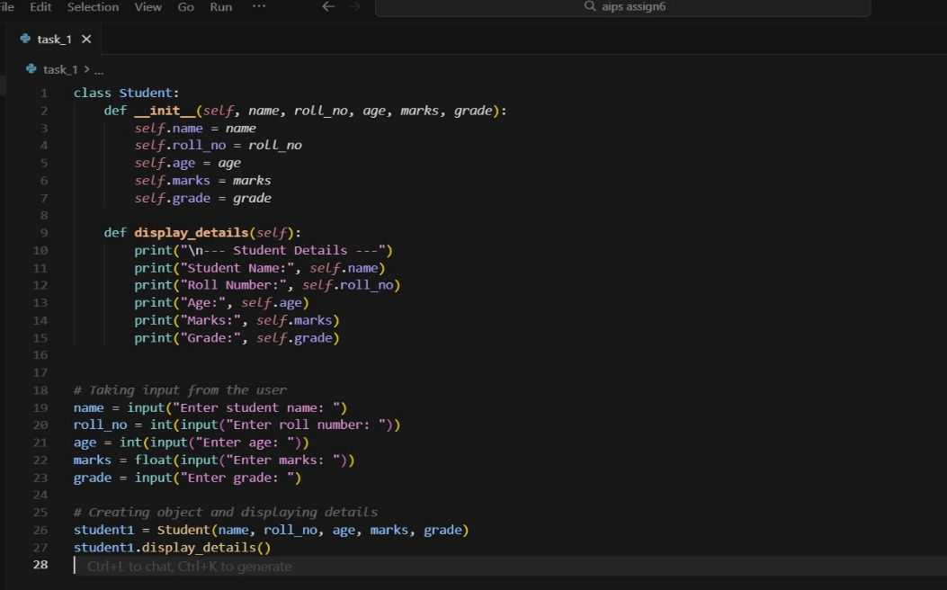  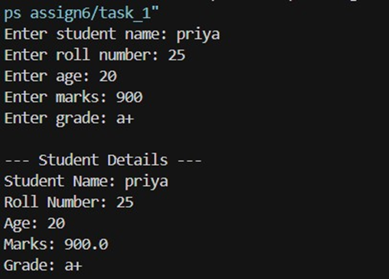  Task Description#2 (Loops)  - Prompt AI to complete a function that prints the first 10 multiples of a number using a loop.  - Analyze the generated code  - Ask AI to generate code using other controlled looping  Prompt  write a Python function that prints the first 10 multiples of a given number using a for loop.  Then, regenerate the code using a while loop.  Expected Output#2  - Correct loop-based implementation  For loop:  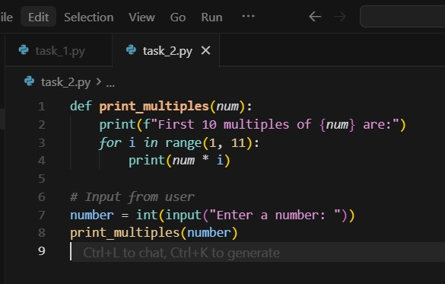  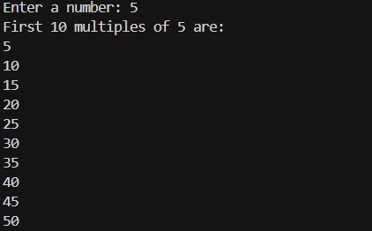  While loop:  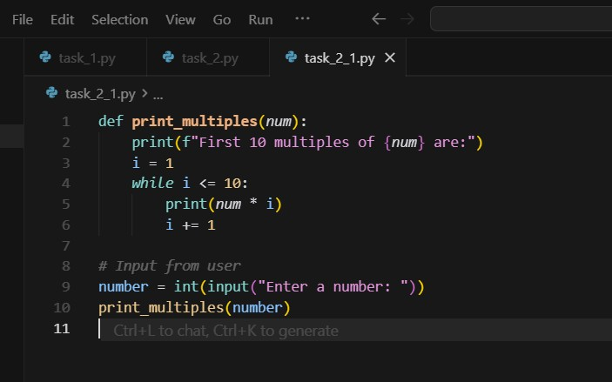  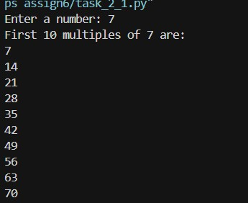  Code Analysis  For Loop Version:  Uses a count-controlled loop (for i in range(1, 11)).  Iterates exactly 10 times — from 1 to 10.  Multiplies the given number by each iteration value to print its multiples.  While Loop Version:  Uses a condition-controlled loop (while i <= 10).  Requires explicit initialization (i = 1) and manual increment (i += 1).  Produces the same result as the for-loop, but demonstrates different control logic.  Task Description#3 (Conditional Statements)  - Ask AI to write nested if-elif-else conditionals to classify age groups.  - Analyze the generated code  - Ask AI to generate code using other conditional statements  Prompt: write a Python function that classifies a person’s age group using nested if–elif–else statements.  Then regenerate the code using simple if–elif–else structure.  Expected Output#3  - Age classification function with appropriate conditions and with explanation  Nested if–elif–else:  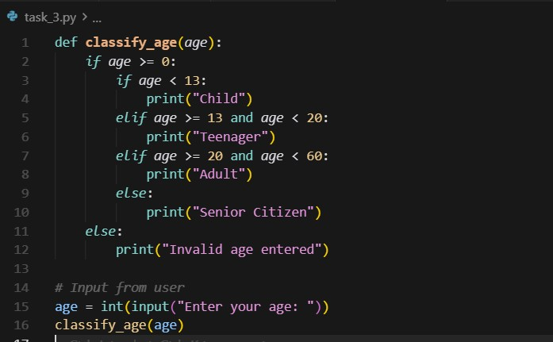  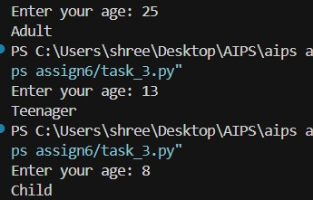  Simple if–elif–else:  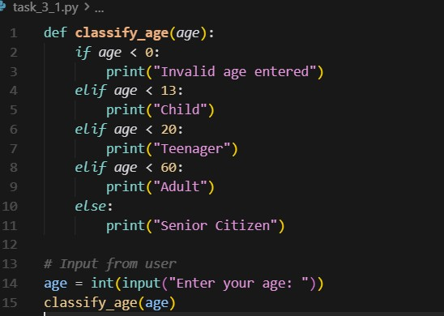  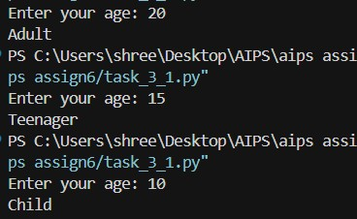  Code Analysis  Nested if–elif–else Version  Uses an outer condition (if age >= 0) to check for valid input.  Inside it, nested conditions classify age into groups.  Demonstrates hierarchical decision-making — one condition leads to another level.  Simple if–elif–else Version  Uses sequential conditional checks without nesting.  Easier to read and maintain while producing the same logical result.  Covers all valid and invalid age ranges with clear boundaries.  Task Description#4 (For and While loops)  - Generate a sum_to_n() function to calculate sum of first n numbers  - Analyze the generated code  - Get suggestions from AI with other controlled looping  Expected Output#4  - Python code with explanation  Prompt: Use AI to write a Python function sum_to_n() that calculates the sum of the first n natural numbers using a for loop, Then regenerate the same function using a while loop.  for loop:  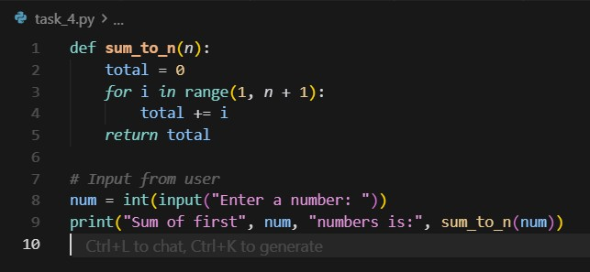  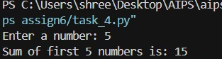  while loop:  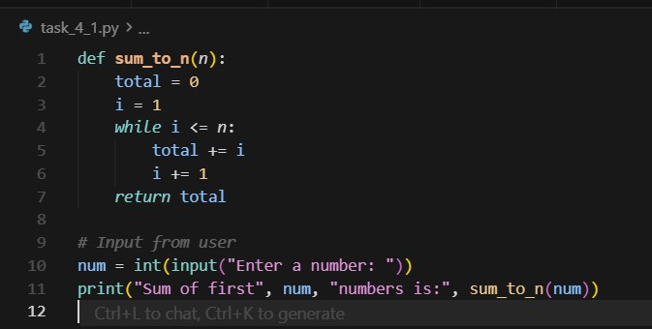  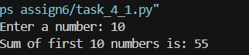  Code Analysis  For Loop Version  - Uses a count-controlled loop (for i in range(1, n + 1)).  - Iterates exactly n times.  - Adds each number sequentially to total.  - Efficient for fixed iteration counts.  While Loop Version  - Uses a condition-controlled loop.  - Requires manual initialization (i = 1) and increment (i += 1).  - Offers more flexibility but slightly longer code.  Task Description#5 (Class)  - Use AI to build a BankAccount class with deposit, withdraw, and balance methods.  - Analyze the generated code  - Add comments and explain code  Expected Output#5  - Python code with explanation  Prompt: Use AI to build a Python program that defines a BankAccount class with methods to deposit, withdraw, and check balance.  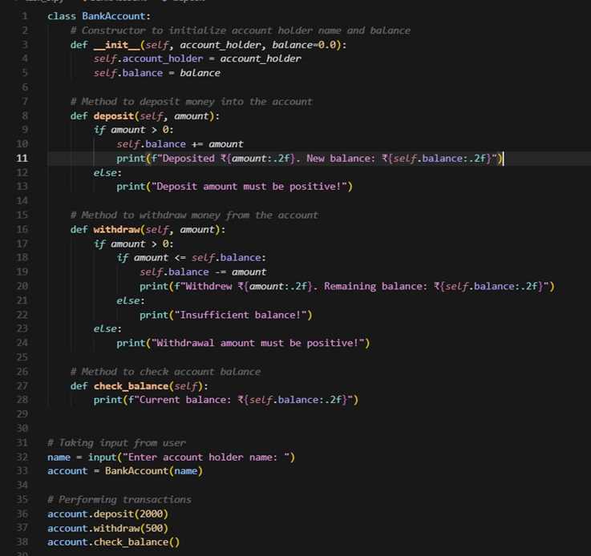  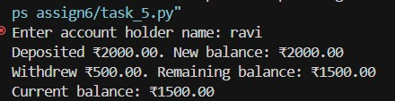  Code Analysis:  Class Definition: BankAccount represents a real-world bank account using OOP and encapsulation.  Constructor: Initializes account holder name and optional balance (default 0.0).  deposit(): Adds money if the amount is positive and shows updated balance.  withdraw(): Allows withdrawal if funds are sufficient; else shows an error.  check_balance(): Displays the current account balance.  User Interaction:Accepts user input for name and performs deposit, withdraw, and balance operations.  Note: Report should be submitted a word document for all tasks in a single document with prompts, comments & code explanation, and output and if required, screenshots  Evaluation Criteria: |  |  |  |  |  | Week3 - Wednesday
  Criteria | Max Marks
  Class | 1.0
  Loops | 1.0
  Conditional Statements | 0.5
  Total | 2.5 Marks

